**Dhina Thayaalan G** 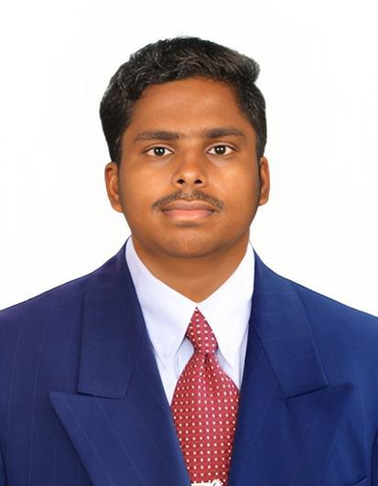

**Phone** : 9789311658

**Email** : dhinathayaalang@gmail.com

**LinkedIn** : <https://www.linkedin.com/in/dhina-thayaalan-768ba71b7>

**GitHub** : https://github.com/Dhinathayaalan

**Address** : 10/228, Bungalowmedu, Doddampalayam, Sathyamangalam-638451

**Career Objective:**

Seeking an entry-level position to begin my career in a high-level professional environment.

**Academic Background:**

|  |  |  |  |
| --- | --- | --- | --- |
| **Qualification** | **Name of the Institution** | **Passing year** | **Marks in CGPA/percentage** |
| B.E-ECE | Karpagam Academy of Higher Education | 2021-2025 | 8.88  (up to 5th semester) |
| HSC | Adharsh Vidhyalaya Higher Secondary School | 2020 | 79% |
| SSLC | SRT Universal Matriculation Higher  Secondary School. | 2018 | 94.2% |

**Technical Knowledge:**

* C.
* Python.
* SQL.

**Area of Interest:**

* Software Development.
* Database Management.

**Certificates:**

* Certified on Learning C by Dan Gookin in LinkedIn Learning.
* Certified on Introduction to Cyber Security from Infosys.
* Certified on Introduction of Artificial Intelligence from Infosys.
* Certified on Excel Basics for Data Analysis from IBM.
* Certified on Introduction to C from Solo learn.

**Workshop:**

* Attended a workshop on Advancement in Optical Communication in IIT Madras, Chennai.
* Attended a workshop on Computer vision for real time application Coimbatore Institute of Technology, Coimbatore.
* Attended a workshop on Embedded Systems using Arduino uno in Karpagam College Engineering, Coimbatore.

**Strength:**

* Contributive.
* Analytical thinking.
* Innovative.

**Declaration:**

All the information shared in the resume is correct and I take full responsibility for its correctness.

Date:

Place:

Dhina Thayaalan G